ONEWAY Prec BY Gender1
/STATISTICS DESCRIPTIVES HOMOGENEITY WELCH
/PLOT MEANS
/MISSING ANALYSIS.

Oneway

Notes
Output Created |  | 05-May-2019 23:10:49
Comments
Input | Active Dataset | DataSet0
Input | Filter | <none>
Input | Weight | <none>
Input | Split File | <none>
Input | N of Rows in Working Data File | 30
Missing Value Handling | Definition of Missing | User-defined missing values are treated as missing.
Missing Value Handling | Cases Used | Statistics for each analysis are based on cases with no missing data for any variable in the analysis.
Syntax |  | ONEWAY Prec BY Gender1  /STATISTICS DESCRIPTIVES HOMOGENEITY WELCH  /PLOT MEANS  /MISSING ANALYSIS.
Resources | Processor Time | 00 00:00:00.172
Resources | Elapsed Time | 00 00:00:00.171

[DataSet0]

Descriptives
 | N | Mean | Std. Deviation | Std. Error | 95% Confidence Interval for Mean
 |  |  |  |  | Lower Bound | Upper Bound
Female | 6 | 36.6667 | 28.04758 | 11.45038 | 7.2325 | 66.1008
Male | 24 | 46.4583 | 38.48995 | 7.85673 | 30.2055 | 62.7112
Total | 30 | 44.5000 | 36.42067 | 6.64947 | 30.9003 | 58.0997

Descriptives
 | Minimum | Maximum
Female | 10.00 | 80.00
Male | .00 | 130.00
Total | .00 | 130.00

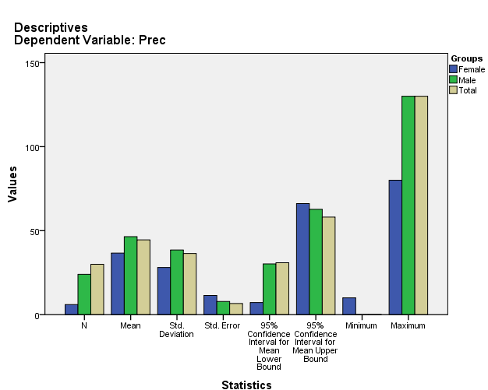

Test of Homogeneity of Variances
Prec
Levene Statistic | df1 | df2 | Sig.
.439 | 1 | 28 | .513

ANOVA
Prec
 | Sum of Squares | df | Mean Square | F | Sig.
Between Groups | 460.208 | 1 | 460.208 | .339 | .565
Within Groups | 38007.292 | 28 | 1357.403
Total | 38467.500 | 29

Robust Tests of Equality of Means
Prec
 | Statisticª | df1 | df2 | Sig.
Welch | .497 | 1 | 10.319 | .496
a. Asymptotically F distributed.

Means Plots

